Day 1

=====

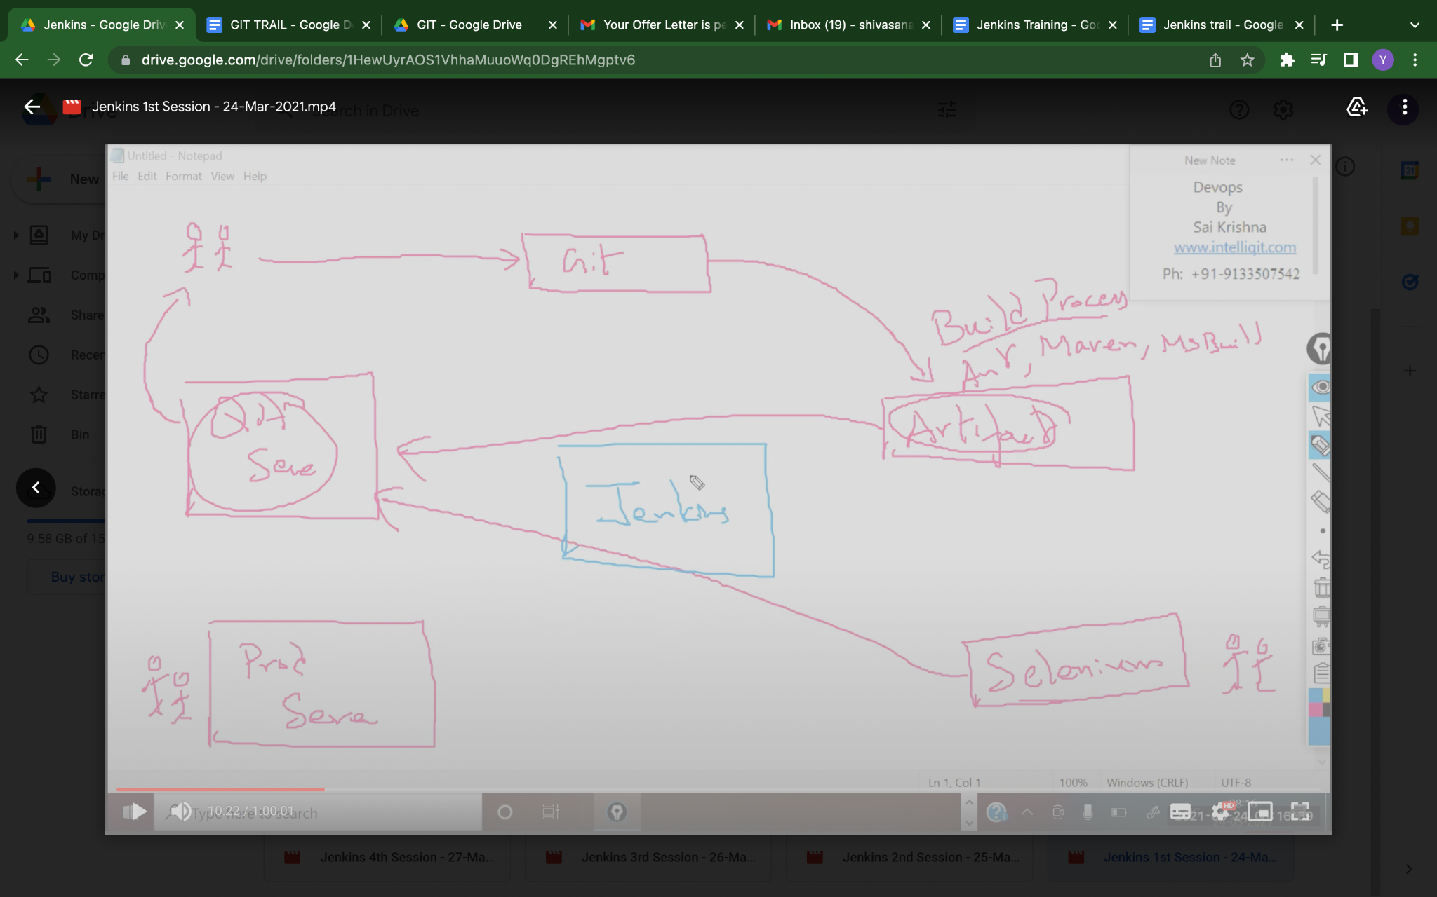

In any organisation this happens. So we have developers and their work is to create code and send that code to some code repository or version control system like Git.

So can we directly send that code to our client? NO

Because the client is interred in application not code, he wants to access the website.

So this code this converted into setup files (.exe)which is called as artifacts.

The process of converting those codes to artifacts called as build process. And to trigger this build process, we use tools like ANT, MAVEN. Via this tool, the code is converted into set up files or artifacts.

This artifacts will not directly send to clients. So they will deploy into the testing servers. In qa servers they will deploy. Here qa people also test this via some automation tools. And if they find error they will send that to developers again new artifact is created and deployed in qa servers until it is defect free.

Then this will deployed in Production servers, where end users or client can access this.

So this complete flow we will be automating using one tool called JENKINS.

As a devops engineer, we need to set up this entire CI-CD.

Java -jar, war

.net -exe

—--------------------------------------------------------

Day2

====

Create 3 servers.

Jenkins server

Qa server

Production server and set up this activities.

After creating serevres eed to connect them using git. Git acts like interface to connect.

Just copy ssh id. In git

